📶 Internet Usage Plan Advisor
A Machine Learning–Based Web Application using Lasso Regression

Abstract
With the rapid growth of internet-based activities such as video streaming, social media usage, online education, and gaming, users often struggle to estimate their actual data consumption and select suitable internet plans. This project, Internet Usage Plan Advisor, uses Lasso Regression, a supervised machine learning technique, to predict a user’s monthly internet usage based on weekly activity patterns. The system then categorizes users and recommends the most appropriate internet data plan. The application is implemented using Python, Scikit-learn, and Streamlit, providing an interactive and user-friendly web interface.

GITHUB LINK https://github.com/Rickshitha-coder/Machine-Learning-Project1-unit-2
WEBSITE LINK https://machine-learning-project1-unit-2-blpynlnnzmwnppldx6f92m.streamlit.app/
Introduction
Internet data consumption has become an essential part of daily life. Due to unpredictable usage patterns, users frequently choose inappropriate data plans, leading to either unnecessary expenses or insufficient data availability.
Machine learning techniques can help analyze usage behavior and make accurate predictions. This project applies Lasso Regression, a regularized linear regression model, to estimate monthly internet usage and assist users in selecting the best plan.

Objectives of the Project
The main objectives of this project are:
- To predict monthly internet usage (in GB)
- To analyze user behavior based on weekly activity
- To categorize users into Light, Moderate, and Heavy users
- To recommend a suitable internet data plan
- To demonstrate practical usage of Lasso Regression
- To build an interactive Streamlit web application

Scope of the Project
This project focuses on:
- Individual user-level internet usage prediction
- Educational and real-world application of machine learning
- A scalable framework that can be extended with real ISP data

Technologies Used
Programming Language
- Python
Libraries & Tools
- Pandas – Data handling and manipulation
- NumPy – Numerical computation
- Scikit-learn – Machine learning modeling
- Streamlit – Web application framework
Machine Learning Algorithm
- Lasso Regression (L1 Regularization)

Dataset Description
The dataset internet_usage_data.csv contains user internet activity details.
Input Features
Feature | Description
streaming_hours | Weekly video streaming hours
social_media_hours | Weekly social media usage
online_classes_hours | Weekly online classes/work hours
gaming_hours | Weekly gaming hours
devices | Number of connected devices
Target Variable
Column | Description
monthly_usage_gb | Monthly internet usage in GB

Methodology
- Data Loading
The dataset is loaded using Pandas and separated into features (X) and target (y).
- Data Splitting
The dataset is split into:
- 80% training data
- 20% testing data
- Feature Scaling
StandardScaler is used to normalize feature values to improve model performance.
- Model Selection
Lasso Regression is selected due to its ability to:
- Perform feature selection
- Reduce overfitting
- Improve generalization
- Model Training
The model is trained using the training dataset.
- Model Evaluation
Performance is evaluated using R² Score, which measures prediction accuracy.

Why Lasso Regression is Used
Lasso Regression is used because:
- It performs automatic feature selection
- Reduces overfitting using L1 regularization
- Produces simpler and interpretable models
- Works well with correlated features
- Provides stable predictions for real-world usage data

System Architecture
User Input (Streamlit UI)
↓
Data Preprocessing (Scaling)
↓
Lasso Regression Model
↓
Monthly Usage Prediction
↓
User Category Classification
↓
Internet Plan Recommendation
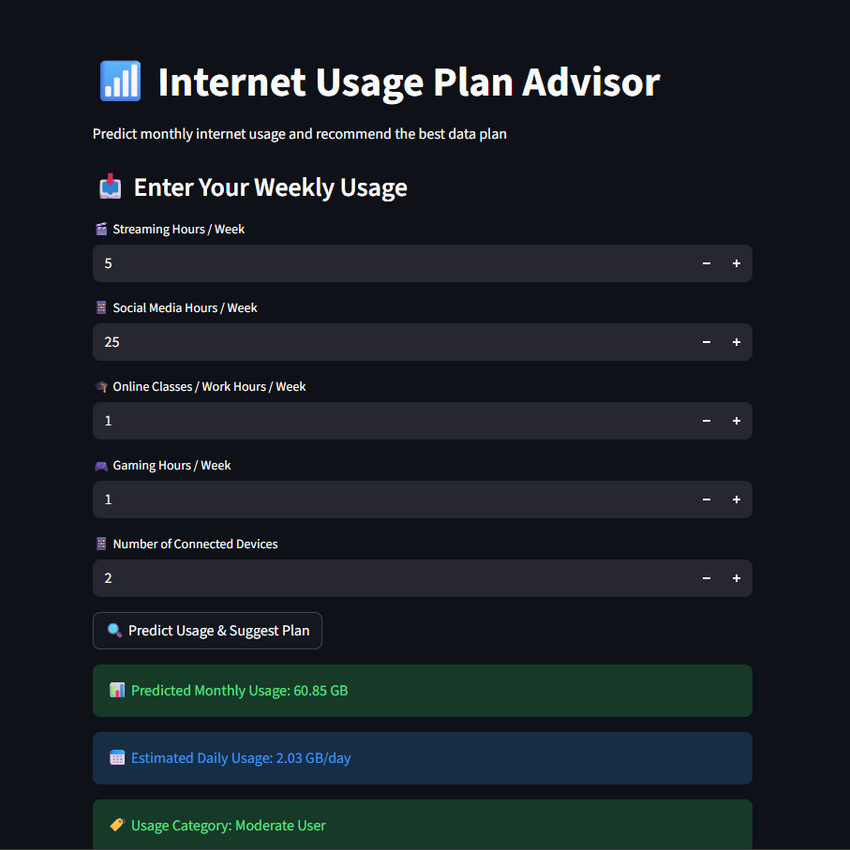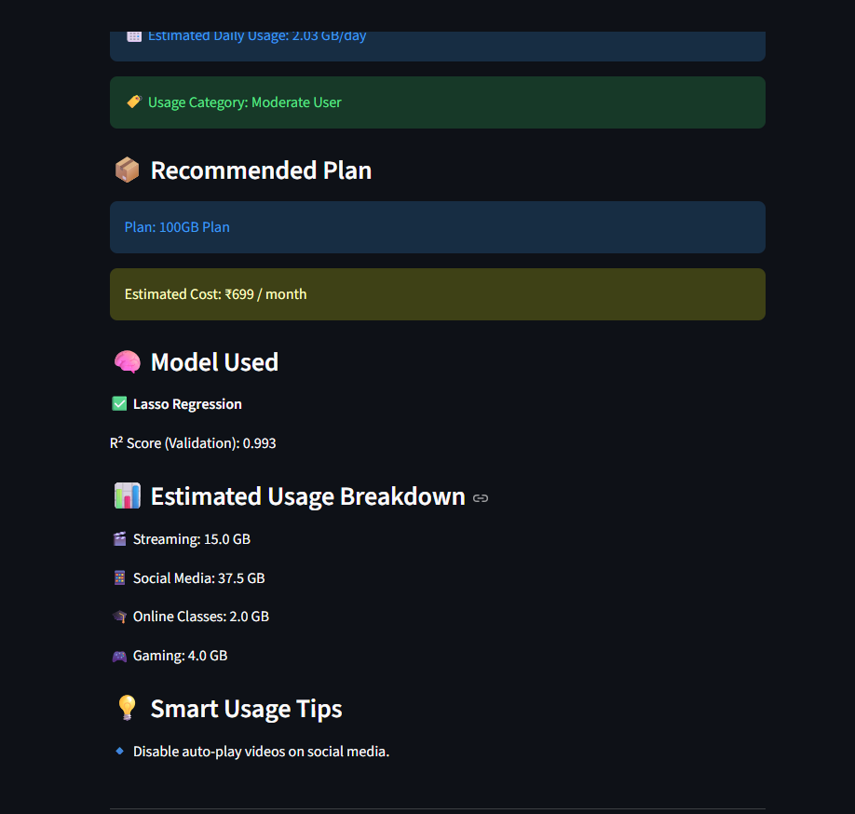
Application Features
- Interactive user interface
- Real-time predictions
- Monthly & daily usage estimation
- User category identification
- Internet plan recommendation
- Smart data usage tips
- Model accuracy display (R² Score)

Plan Recommendation Logic
Monthly Usage | Category | Recommended Plan
≤ 50 GB | Light User | 50GB – ₹399
51–100 GB | Moderate User | 100GB – ₹699
> 100 GB | Heavy User | Unlimited – ₹999

Results and Output
- Predicts monthly internet usage accurately
- Displays daily usage estimates
- Suggests cost-effective plans
- Provides usage optimization tips
- Shows model performance metrics

Advantages
- Helps users choose optimal data plans
- Reduces unnecessary expenses
- Easy to use and understand
- Practical ML implementation

Limitations
- Depends on dataset quality
- Limited to predefined features
- Real-world usage variations are not fully captured

Conclusion
The Internet Usage Plan Advisor demonstrates how machine learning can be applied to solve practical problems. By using Lasso Regression, the system predicts internet usage efficiently while avoiding overfitting. The application provides accurate predictions, user-friendly recommendations, and valuable insights, making it suitable for both academic and real-world use.

